**Project Design Phase-II**

**Technology Stack (Architecture & Stack)**

|  |  |
| --- | --- |
| Date | 03October 2022 |
| Team ID | PNT2022TMID14038 |
| Project Name | Exploratory Analysis of Rainfall Data in India for Agriculture |
| Maximum Marks | 4 Marks |

**Technical Architecture:**

The Deliverable shall include the architectural diagram as below and the information as per the table1 & table 2

**Example: Order processing during pandemics for offline mode**

**Reference:** [**https://developer.ibm.com/patterns/ai-powered-backend-system-for-order-processing-during-pandemics/**](https://developer.ibm.com/patterns/ai-powered-backend-system-for-order-processing-during-pandemics/)

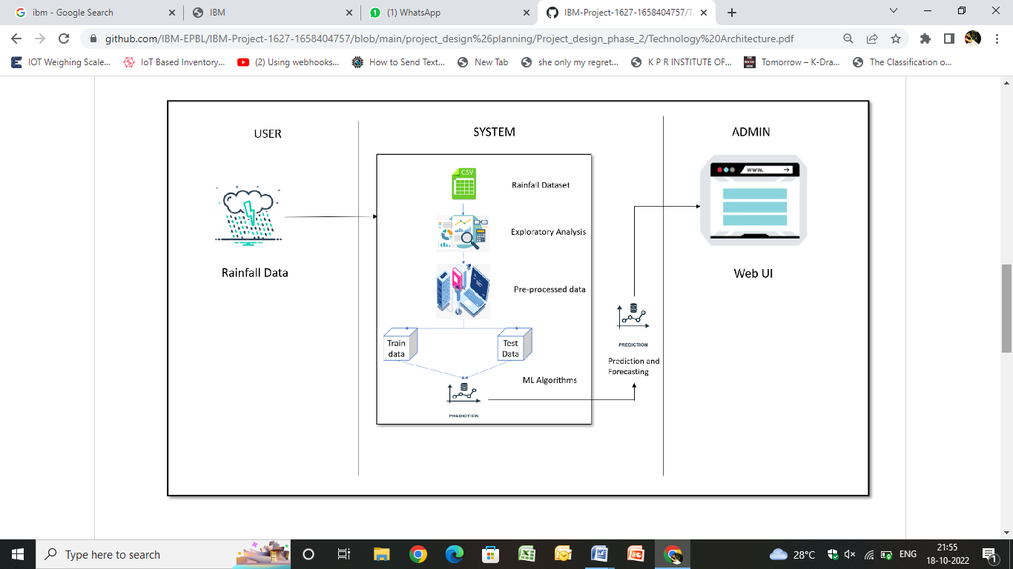

**Table-1 : Components & Technologies:**

|  |  |  |  |
| --- | --- | --- | --- |
| **S.No** | **Component** | **Description** | **Technology** |
|  | User Interface | How user interacts with application e.g.  Web UI, Mobile App, Chatbot etc. | HTML, CSS, JavaScript / Angular Js / React Js etc. |
|  | Database | The place where data can be stored and retrieved during the execution of the application | CSV Store,NoSQL |
|  | Cloud Database | Used for integrating components while using python flask | IBM DB2,IBM Cloudant |
|  | API | Used to call the functions in order to access the execution in another framework | Python Flask,Node Js(if needed) |
|  | Application logics | Data Type, Configurations etc. | Python,javascript |
|  | Machine Learning Model | Database Service on Cloud | Sklearn Regressors,ML Algorithms,XGBoost |
|  | Data Pre-processing and Analysis | File storage requirements | Numpy,Matplotlib,Pandas,  Seaborn,Geopandas |

**2: Application Characteristics:**

| **S.No** | **Characteristics** | **Description** | **Technology** |
| --- | --- | --- | --- |
|  | Open-Source Frameworks | Backend Framework,Non-structured Database,CSS Framework styling | Python Flask/NodeJS,MongoDB,IBM DB2,CSS-3 |
|  | Security Implementations | Email verification and authentication,Authentication and authorisation using JSON object by comparing the data exists in database | SSL Certs,Direct Verification using Backend Framework |
|  | Scalable Architecture | To ensure that enough resource is allocated on the | IBM Cloud Cabernets Service |
|  | Availability | The website will be made available by hosting it in cloud hosting platforms. | Heroku cloud hosting(for testing)  IBM Cloud hosting |
|  | Performance | Multiple prediction requests should be handled simultaneously without affecting the speed and accuracy of prediction. | Load Balancers and Distributed Services |

**References:**

[**https://c4model.com/**](https://c4model.com/)

[**https://developer.ibm.com/patterns/online-order-processing-system-during-pandemic/**](https://developer.ibm.com/patterns/online-order-processing-system-during-pandemic/)

[**https://www.ibm.com/cloud/architecture**](https://www.ibm.com/cloud/architecture)

[**https://aws.amazon.com/architecture**](https://aws.amazon.com/architecture)

[**https://medium.com/the-internal-startup/how-to-draw-useful-technical-architecture-diagrams-2d20c9fda90d**](https://medium.com/the-internal-startup/how-to-draw-useful-technical-architecture-diagrams-2d20c9fda90d)